AngularJS Tutorial

[« W3Schools Home](http://www.w3schools.com/default.asp)

[Next Chapter »](http://www.w3schools.com/angular/angular_intro.asp)

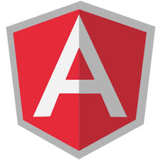

AngularJS extends HTML with new attributes.

AngularJS is perfect for Single Page Applications (SPAs).

AngularJS is easy to learn.

Learn AngularJS now!

This Tutorial

This tutorial is specially designed to help you learn AngularJS as quickly and efficiently as possible.

First, you will learn the basics of AngularJS: directives, expressions, filters, modules, and controllers.

Then you will learn everything else you need to know about AngularJS:

Events, DOM, Forms, Input, Validation, Http, and more.

Try it Yourself Examples in Every Chapter

In every chapter, you can edit the examples online, and click on a button to view the result.

AngularJS Example

<!DOCTYPE html>  
<html lang="en-US">  
<script src="http://ajax.googleapis.com/ajax/libs/angularjs/1.4.8/angular.min.js"></script>  
<body>  
  
<div ng-app="">  
  <p>Name : <input type="text" ng-model="name"></p>  
  <h1>Hello {{name}}</h1>  
</div>  
  
</body>  
</html>

[Try it Yourself »](http://www.w3schools.com/angular/tryit.asp?filename=try_ng_default)

What You Should Already Know

Before you study AngularJS, you should have a basic understanding of:

* HTML
* CSS
* JavaScript